< Garrett Bachman >

< August 8 2021 >

< [IT FDN 110 B](https://canvas.uw.edu/courses/1474822) >

< Assignment 05 Knowledge Documentation >

Knowledge Documentation

Introduction

This document follows my process through module 5’s material and labs, as well as the final project at the end. This module introduced the very unique dictionaries, which made this seemingly short module very brain-wracking and confusing.

Lab05-A

The start of the module covered using .split() as well as .strip(), and also reviewed some information regarding lists and saving to files. The first lab of module 4 was a lot more difficult compared to all the previous Lab As, but I was still able to finish it after some time. The lab gave the user options to manipulate their CD library, similarly to the last module’s assignment.

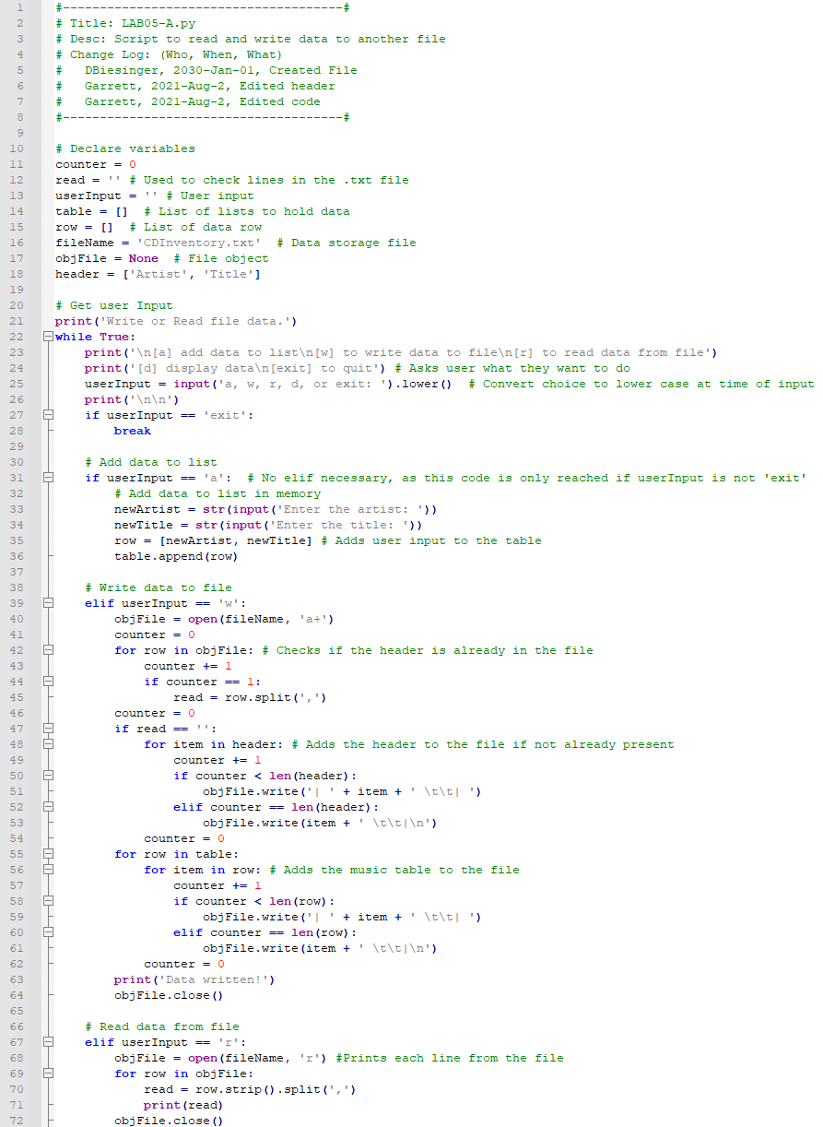

*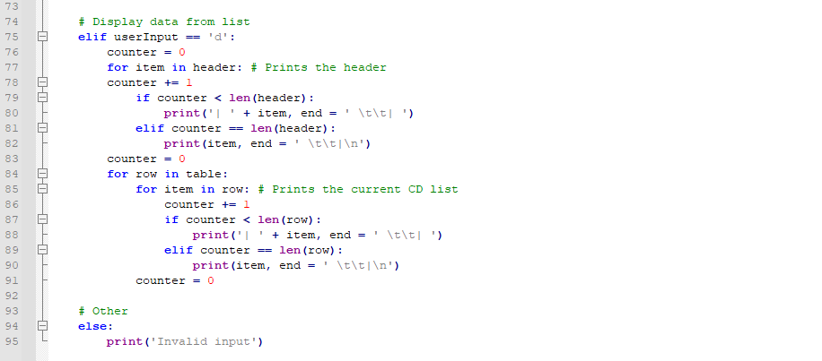Figure 1, 2 - LAB05-A’s Code. The Code Was So Long That I Had to Split it Into Multiple Screenshots For It to Show on the Page Properly*

This is the lab in the Anaconda Prompt

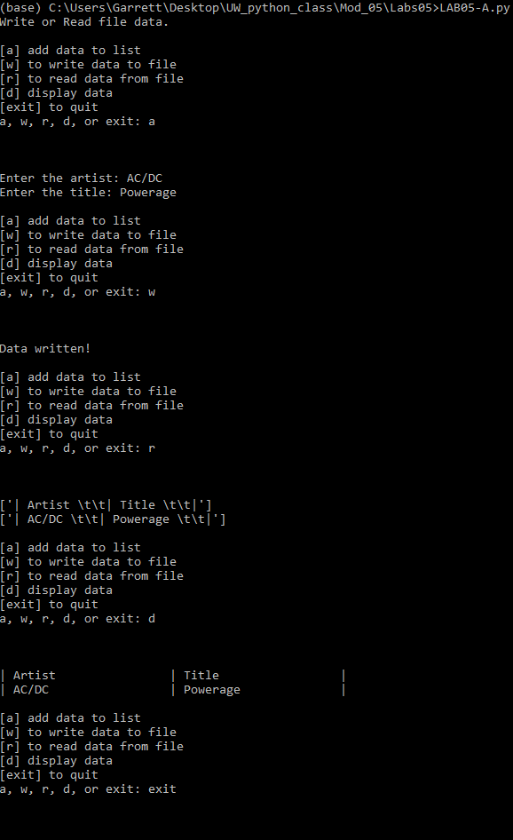

*Figure 3 - LAB05-A After Running in the Anaconda Prompt*

And here is the final result in the .txt file

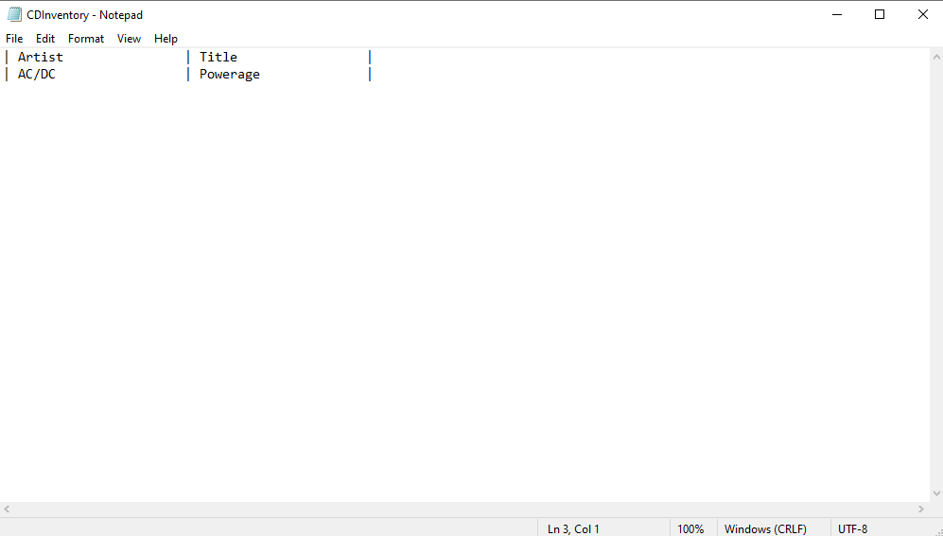

*Figure 4 - CDInventory.txt After Receiving Information from LAB05-A*

The code starts out by starting a loop then asking the user what they want to do. Typing in ‘a’ asks the user to input a CD title and artist, then adds the data to a list. Typing ‘w’ saves the data in the list to a separate file. Typing in ‘r’ reads the data in the other file, then prints it. Finally, typing ‘d’ simply prints out the data in the list. Additionally, the user can type exit to leave the program.

Lab05-B

This part of the module introduced dictionaries. This lab improved upon lab05-B by replacing a list with a dictionary, as well as improving many smaller aspects.

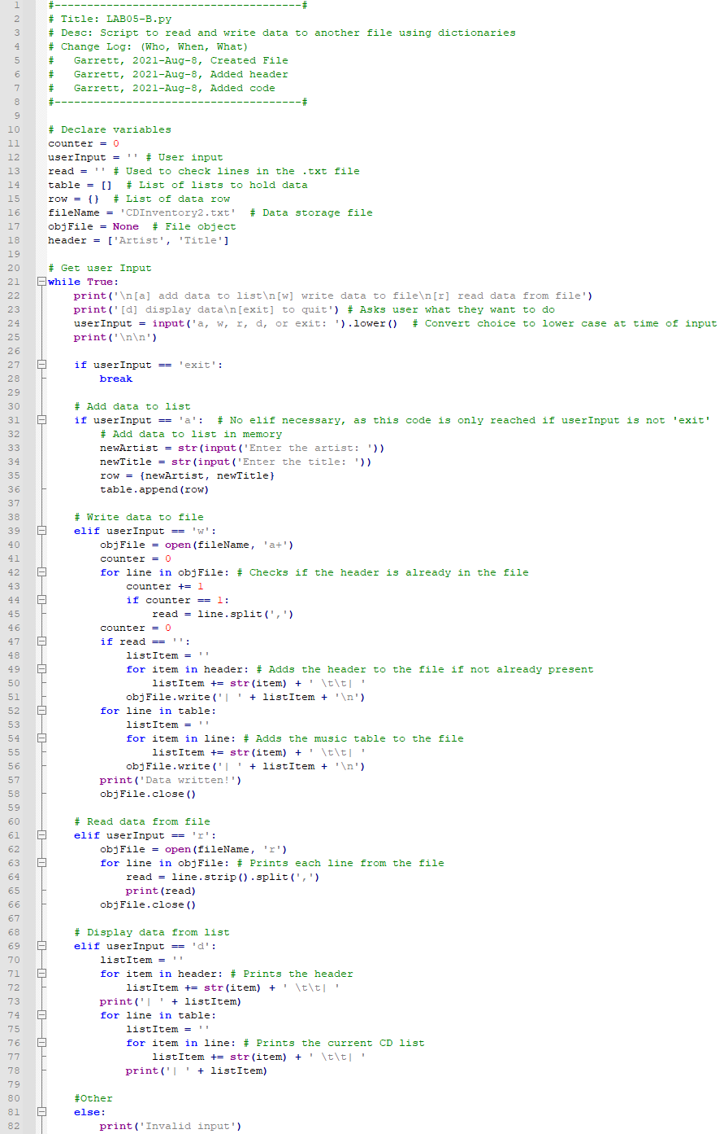

*Figure 5 - LAB05-B’s Code. The Code Was too Large to Fit into the* [*Syntax Highlighter*](https://highlight.hohli.com/index.php) *(external reference)[1], So I Used Notepad++'s Automatic Highlighting Feature Instead*

This is the program after running

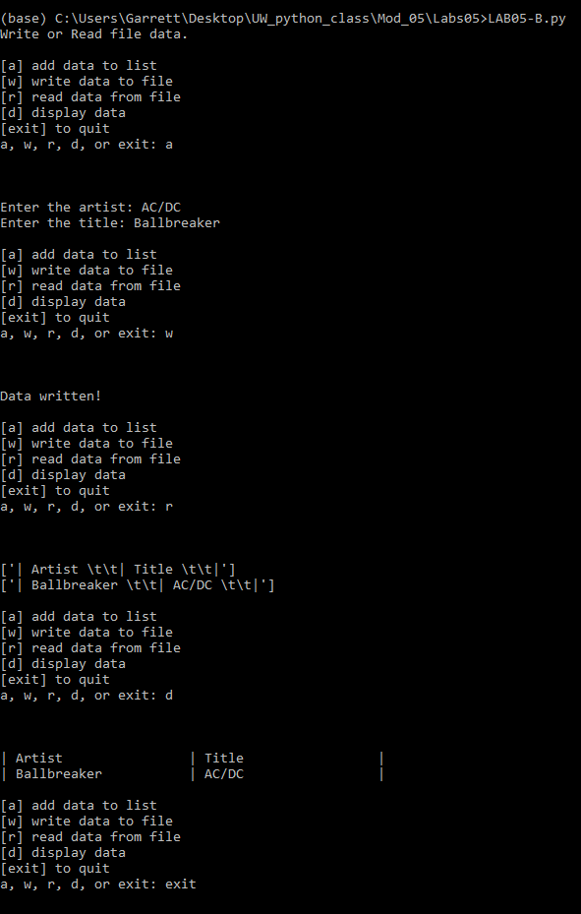

*Figure 6 - LAB05-B After Running in the Anaconda Prompt*

And this is the text file

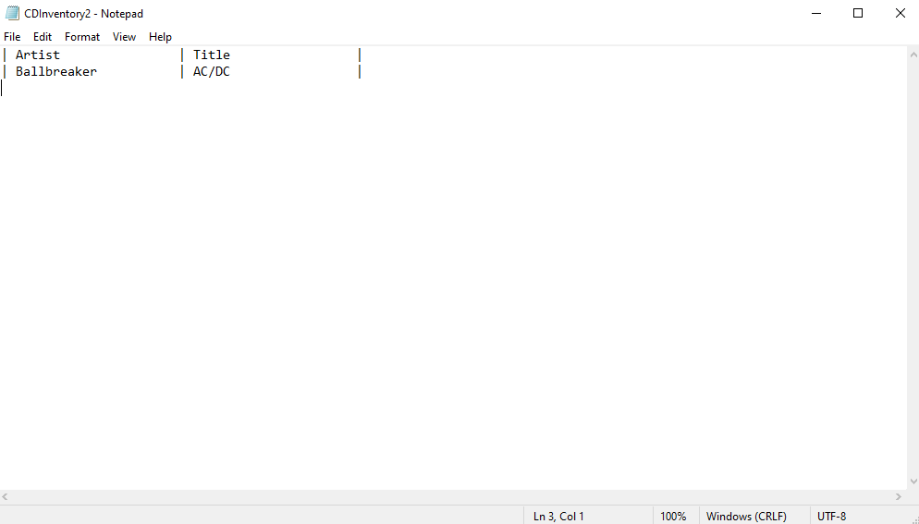

*Figure 7 - CDInventory2.txt After Receiving Information from LAB05-B*

The code runs almost exactly like the previous lab, but has some improvements. I used a different set of code for the list printing and writing, shortening the lines used. I tested some other things, but I couldn't get them to work. After that, I couldn't find anything else to improve on, so I just left it as it was.

Viewing Additional Content

I read all three of the articles linked in the assignment page. The first article, [Lists and Tuples in Python](https://realpython.com/python-lists-tuples/) (external reference)[2], reviewed using lists, indexes, nested lists, appending and removing from lists, as well as using tuples. The second article, [Dictionaries in Python](https://realpython.com/python-dicts/) (external reference)[3], reviewed using dictionaries and dictionary-related methods. The third article, [File Handling in Python](https://www.geeksforgeeks.org/file-handling-python/) (external reference)[4], reviewed the different modes you could open a file in and what they're used for.

After reading the articles, I moved on to the video. The video, [Python Coding - Reading and Writing to Text Files](https://www.youtube.com/watch?v=m0o0CkYsDzI) (external reference)[5], reviewed reading and writing with separate files.

Applying my Knowledge

After finishing all of that, I started the module 5 assignment. This assignment was a copy of last week’s assignment, but we had to apply our new knowledge to it. The new additions include a loading function as well as a deleting function, which improve the capabilities of our CD library program.

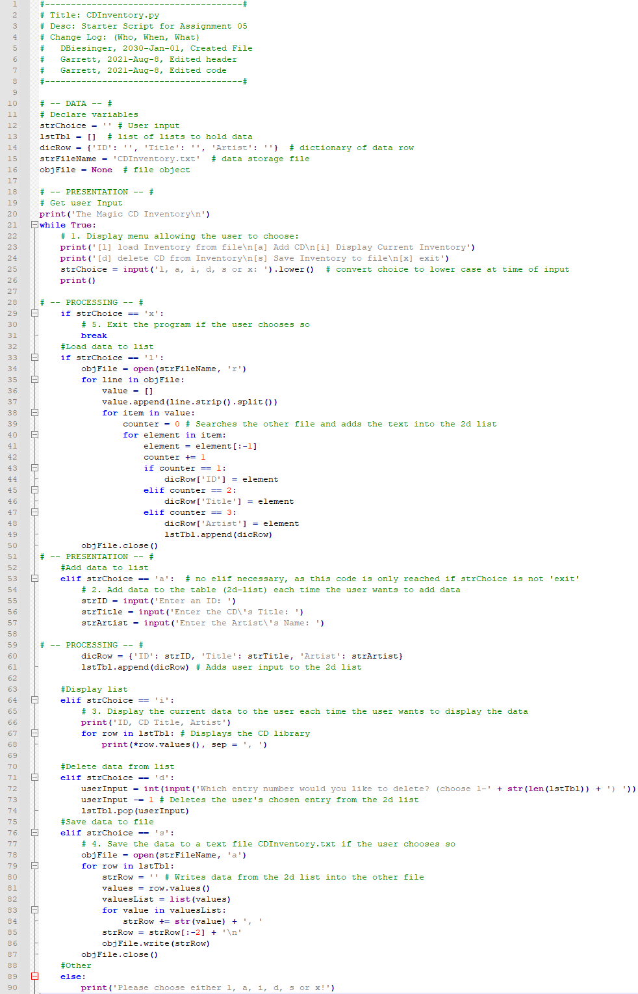

*Figure 9 - AddressBook’s Code. The Code Was too Large to Fit into the* [*Syntax Highlighter*](https://highlight.hohli.com/index.php) *(external reference)[6], So I Used Notepad++'s Automatic Highlighting Feature Instead*

This is the data I entered into the Anaconda Prompt:

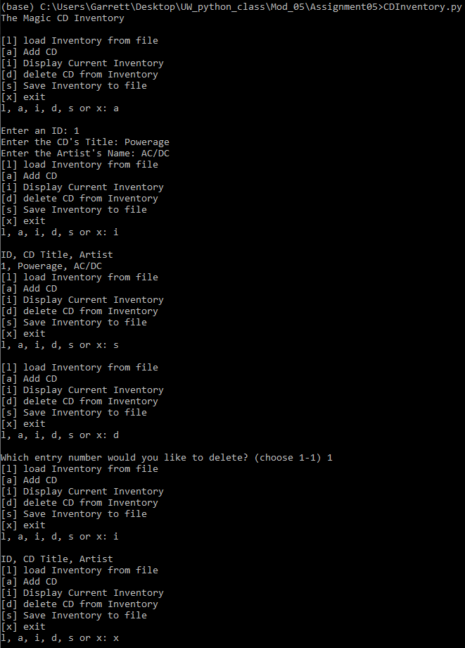

*Figure 10 - CDInventory After Running in the Anaconda Prompt*

I didn’t demonstrate the loading function as there was nothing in the file beforehand so nothing would’ve happened. Anyways, here's the .txt file.

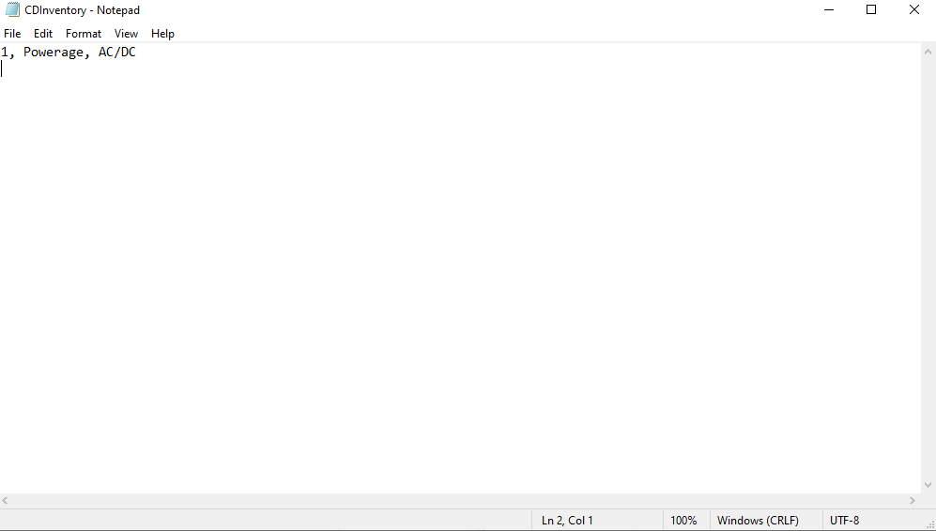

*Figure 12 - CDInventory.txt after I entered the data.*

The code has so many different choices, so I'll go over each one briefly. ‘X’ quits the program when inputted by the user. ‘L’ adds the data from the file into the list. ‘A’ lets the user add their own data into the list. ‘D’ deletes an entry from the list that the user chooses. Finally, ‘S’ saves the data from the list into the file. There are still some things that arent working as I intended, but I can't figure out why and this is already a day late, so i'm just going to leave it as it is. If you can figure out how to fix the issues, please let me know.

Summary

This module looked simple on the surface, but ended up being much more challenging than I anticipated. The introduction of dictionaries and their whole new slew of modules made these labs and the assignment much more time-consuming compared to the last four modules.

1. Retrieved July 31 2021
2. Retrieved July 31 2021
3. Retrieved July 31 2021
4. Retrieved July 31 2021
5. Retrieved July 31 2021
6. Retrieved July 31 2021